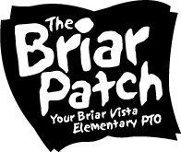

Ready

to Dance?

Join us for

second annual

Smalls & talls Dance

Friday, February 9

6:00pm-8:00pm

Have your BVE student grab mom, dad, grandma, grandpa, or any other special person and come party with us!
Tickets will be on sale through Thursday, February 8

Tickets are $15 per person and include entry, dinner, pictures and loads of fun!

Purchase tickets with your homeroom teacher by 2/6 or online by 2/8. Tickets purchased by 2/6 will be sent home in the courier on the 8th. Tickets purchased by 2/8 will be available at the door.
A small amount of tickets will be available to purchase at the door.

For more information, contact briarpatchbve@gmail.com

Check the PTO newsletter or website for updates
http://www.briarvistapto.org

